**Scene segmentation in rural and urban regions from Remote Sensing Data**

**Problem Statement**

Remote sensing data is an important source for creating or updating geographical information system database and are used in different types of areas. Automatic segmentation of remote sensing data into semantically classes has been a classical problem from past decades and has many application areas like maps, navigation, monitoring of environment, planning of urban and rural area etc.. but after such great progresses, it still need more accuracy and efficiency. The problem statement for this work is basically performing the scene segmentation which can be an aerial image of urban and rural area from remote sensing data so that different structures can be identified like road, buildings etc... This task is challenging because of the existence of highly different objects or structure or shapes appear which calls for prior information apart from standard smoothness and co-occurrence assumptions.

**Background**

There has been lot of works done in the area of pixel-wise classification of remote sensing imagery (i.e low resolution images). Now-a-days, more attention is going towards the object or structure detection in urban areas scenarios as high resolution images. So for this, there can be a possible solution which is rule-based approaches which designs customized rules to encode a-priori knowledge for some specific classes. In this approach, when an input image in given, it classifies image pixels into multiple class labels then an over-complete set of roads and building candidate are generated. Next, these generated candidates are pruned to an optimal subset.

**Methodology**

Architecture for scene segmentation for urban scenario from remote sensing data is shown in figure1.

*Step 1: Data collection and dataset preparation*

*Step 2: D*ataset is divided into training dataset for creating the model and test dataset for testing the dataset.

*Step 3: Developing a model for scene segmentation for urban scenario from remote sensing data*

*Step 4: Training and experimentation on datasets*

*Step 5: Testing the model performance in terms of accuracy and running it on real-time data.*

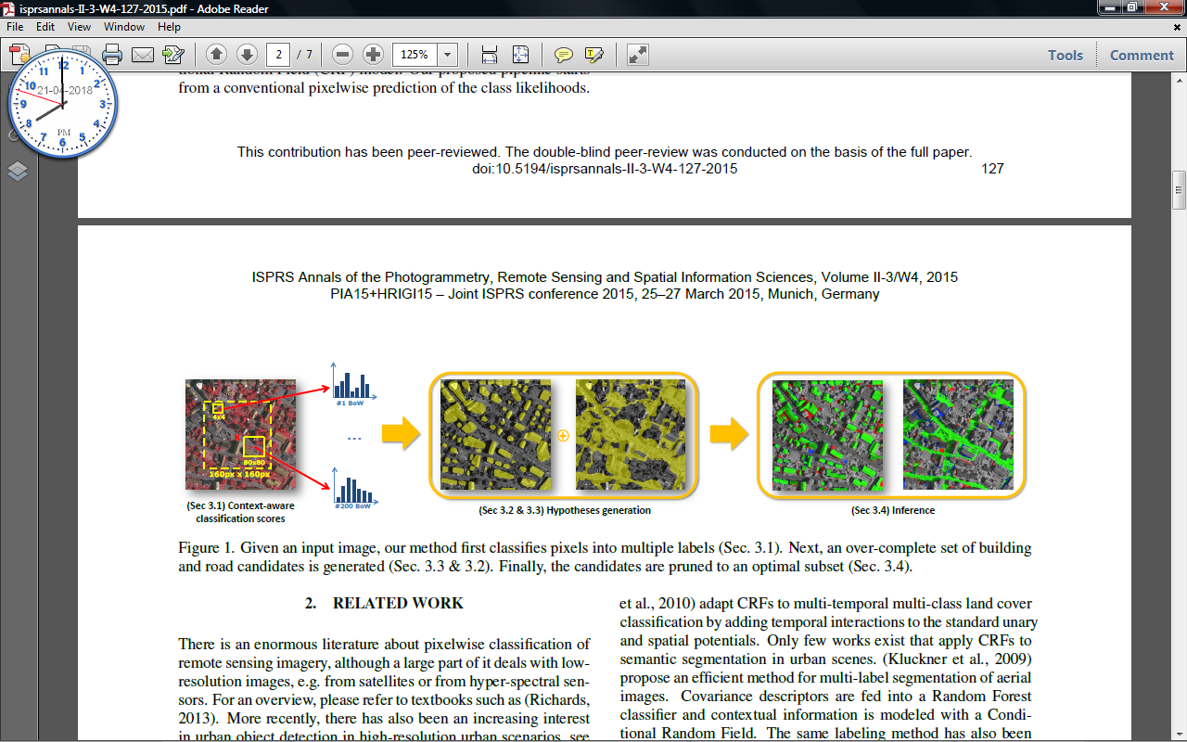

Figure 1: Architecture for scene segmentation for urban areas from remote sensing data [J. A. Montoya-Zegarra, J. D. Wegner, L. Ladický, K. Schindler, "Semantic Segmentation Of Aerial Images In Urban Areas With Class-Specific Higher-Order Cliques", ISPRS Annals of the Photogrammetry, Remote Sensing and Spatial Information Sciences, Volume II-3/W4, 2015 PIA15+HRIGI15 – Joint ISPRS conference 2015, 25–27 March 2015, Munich, Germany]

**Experimental Design**

*Dataset*

Vaihingen dataset can be used for this work.

*Evaluation Measures*

Comparision with other algorithms on the same dataset for pixel-wise classification accuracy in precision and F1 scores for all six classes like Roads (white), Buildings (blue), Trees (green), Asphalt (grey), Grass (turquoise), Background (red).

*Software and Hardware Requirements*

* Anaconda Python
* Tensorflow